WEEK 10
Date: |  | Day: MONDAY |  |  | Strand: All Around Us
 |  |  |  |  | SUB STRAND: Connecting & Communicating With The Global Community
Class: KG 1 |  |  | Class Size:
Content Standard:  K2.7.1.1 Demonstrate understanding of the various ways we connect with the global community. |  |  |  | Indicator:  K2.7.1.1.1 sing or recite poems about the theme and discuss the various ways new connect with the outside world  K2.7.1.1.3 use a variety of new vocabulary learnt about the theme to create an informational text for reading using LEA
Performance Indicator:  - Learners can sing or recite poems about the theme and discuss the various ways new connect with the outside world  - Learners can use a variety of new vocabulary learnt about the theme to create an informational text for reading using LEA |  |  |  |  | Core Competencies:  Communication and collaboration (CC) Personal Development and Leadership (PL) Creativity and Innovation (CI) Critical Thinking and Problem Solving
Keywords: Plant, stem, root, leaves, fruits
Reference : KG Curriculum P.g. 76-79
Phase/Duration | Learners Activities |  |  |  |  | Resources
PHASE 1: STARTER 10 MINS  (Preparing the Brain for Learning) | Have learners the beginning sounds of the following items in the picture below.  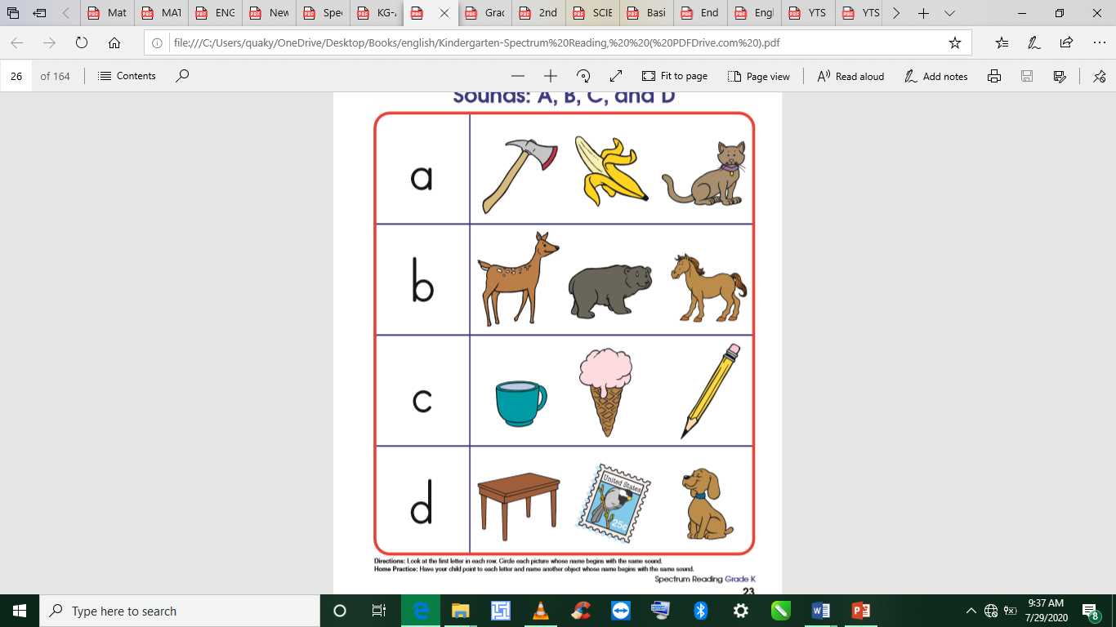
PHASE 2: MAIN 40MINS  (New Learning Including Assessment) | Learners recite the poem” An aero plane is passing”  Follow basic procedures of the community circle time (as in K2.1.1.1.1) and introduce the theme for the week. |  |  |  |  | Poster, Cut out shapes, big books, counters, crayons, cut out foreign currencies
GROUP ACTIVITY 1  (OUTDOOR) | Take Learners out of the class to the field for a stretch up.  Engage Learners to use any of the play toys available.  Make a choice to use any of the learning centers created
PHONICS | Engage learners to sing songs and recite some familiar rhymes that relates to the target sound.  Guide learners to pronounce and write the target sound in the sand tray or exercise books.  Have learners say three or four words that contain the target sound.  Using flash cards, learners read words that contain the target sound.  1. What sound have we learnt today?  2. Which other letter sound do you know?  3. Mention any object in the classroom or home that begins with the target letter sound. |  |  |  |  | Word cards, letter cards.
GROUP ACTIVITY 2  (INDOOR) | Using a Globe or a World map, show learners how big the world is  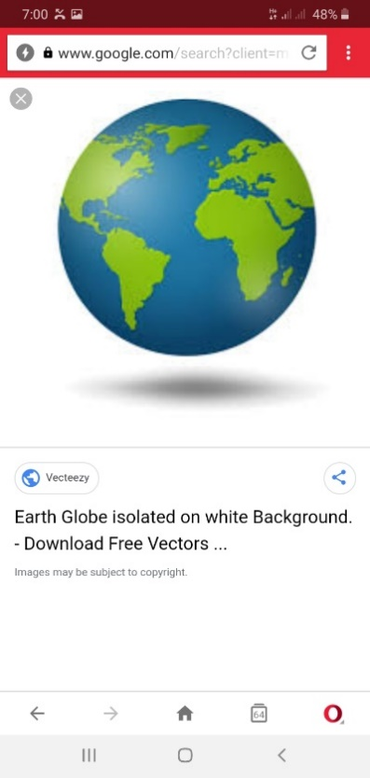  Ask leading questions to make the learners think critically about how we connect with the outside world.  Engage the learners in active discussion on the following: What various modes of transport do people use to connect with the global community? (Aeroplanes and ship)  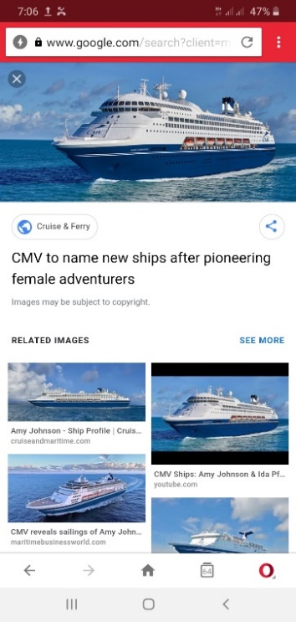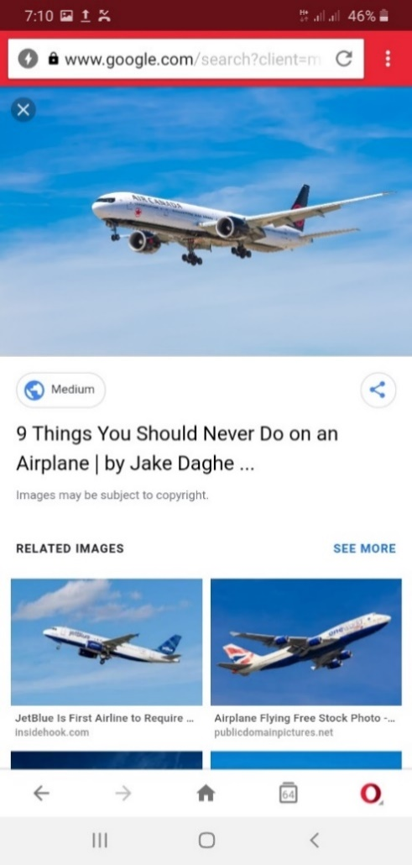  How do people in our country communicate with others? (phones),  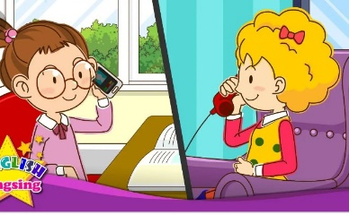  How do we know about these other people? (TV)  Follow the procedure for using the Language Experience Approach (LEA) to create an informational text on the ways we communicate with the global community. |  |  |  |  | Poster, Cut out shapes, big books, counters, crayons, cut out foreign currencies
LEARNING CENTER | Engage learners to play freely at the learning centers.  Observe, join in and ask learners questions frequently to guide their play and to support their understanding in what they are learning. |  |  |  |  | Learning center
STORY SHARING | Tell learners a story.  Pause regularly and ask questions to make sure learners are following.  Engage learners to act parts of the story.  1. Was the story interesting?  2. What part of the story did you like?  3. what have you learnt from the story? |  |  |  |  | Word cards, letter cards.
PHASE 3: REFLECTION 10MINS  (Learner and Teacher) | Review lesson with Learners by singing songs in relation to it

Date: |  | Day: TUESDAY |  |  | Strand: All Around Us
 |  |  |  |  | SUB STRAND: Connecting & Communicating With The Global Community
Class: KG 1 |  |  | Class Size:
CONTENT STANDARD:  K2.7.1.1 Demonstrate understanding of the various ways we connect with the global community. |  |  |  | INDICATORS:  K2.7.1.1.2 participate actively in the shared reading of the big book which relates to the theme and answer simple questions on the text.  K2.7.1.1.4 identify sounds of letters and be able to write them.
PERFORMANCE INDICATOR:  - Learners can participate actively in the shared reading of the big book which relates to the theme and answer simple questions on the text.  - Learners can identify sounds of letters and be able to write them |  |  |  |  | Core Competencies:  Communication and collaboration, Critical thinking, Personal Development and Leadership
Keywords: Plants, medicine, shade
Reference : KG Curriculum P.g. 76-79
Phase/Duration | Learners Activities |  |  |  |  | Resources
PHASE 1: STARTER | Have learners to identify the activities in the pictures below and relate to them.  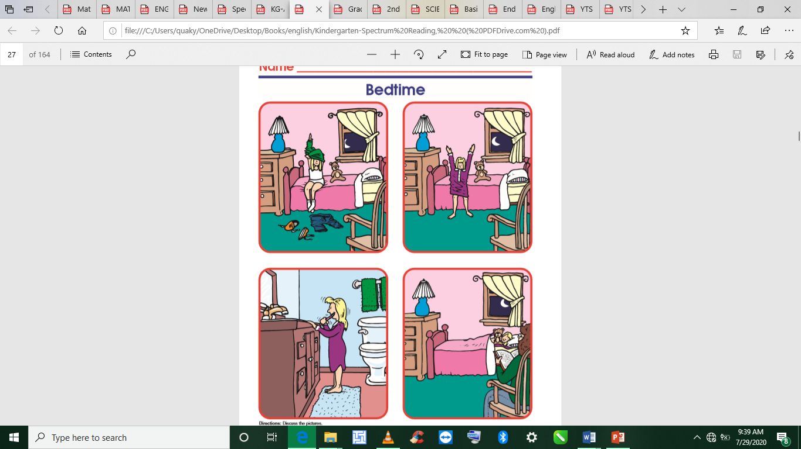
PHASE 2: NEW LEARNING  CIRCLE TIME | In a community circle time, show the book and ask learners to identify the cover page, the writer/author and the illustrator.  Have learners use the cover page illustration and picture walk to predict the content. |  |  |  |  | Poster, Cut out shapes, big books, counters, crayons, cut out foreign currencies
GROUP ACTIVITY 1  (OUTDOOR) | Take Learners out of the class to the field for a stretch up.  Engage Learners to use any of the play toys available.  Make a choice to use any of the learning centers created
PHONICS | Engage learners to sing songs and recite some familiar rhymes that relates to the target sound.  Guide learners to pronounce and write the target sound in the sand tray or exercise books.  Have learners say three or four words that contain the target sound.  Using flash cards, learners read words that contain the target sound.  1. What sound have we learnt today?  2. Which other letter sound do you know?  3. Mention any object in the classroom or home that begins with the target letter sound. |  |  |  |  | Word cards, letter cards.
GROUP ACTIVITY 2  (INDOOR) | Follow the steps of the KWL strategy instruction as you read aloud the informational text on the global community to the learners.  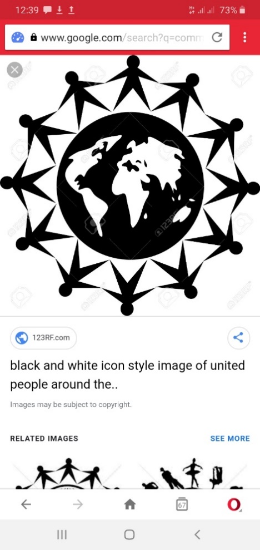  Learners first say what they know about the outside world (K), ask questions on what they want to know, listen as you read, pause often and let learners find answers to their questions.  After reading, have them share the lessons learnt. Encourage students to share their experiences too.  Play Alphabet Relay  Put learners in groups of 4 to compete for letter recognition and writing.  Give each group a piece of chalk.  Call out a letter and let two pupils from each group run to the chalk board and write both the small and capital letter.  Call out another letter and let pupils take turns.  Take Learners out of the class to the field for a stretch up. |  |  |  |  | Poster, Cut out shapes, big books, counters, crayons, cut out foreign currencies
LEARNING CENTER | Engage learners to play freely at the learning centers.  Observe, join in and ask learners questions frequently to guide their play and to support their understanding in what they are learning. |  |  |  |  | Learning center
STORY SHARING | Tell learners a story.  Pause regularly and ask questions to make sure learners are following.  Engage learners to act parts of the story.  1. Was the story interesting?  2. What part of the story did you like?  3. what have you learnt from the story? |  |  |  |  | Word cards, letter cards.
PHASE 3: REFLECTION | Review lesson with Learners by singing songs in relation to it.

Date: |  | Day: WEDNESDAY |  |  | Strand: All Around Us
 |  |  |  |  | Sub Strand: Connecting & Communicating With The Global Community
Class: KG 1 |  |  | Class Size:
CONTENT STANDARD:  K2.7.1.1 Demonstrate understanding of the various ways we connect with the global community |  |  |  | INDICATORS:  K2.7.1.1.5 identify letter-sounds in key words about the theme and be able to write them in their books.  K2.7.1.1 6 sing songs from different cultures and languages (French songs) and perform actions on them.
PERFORMANCE INDICATOR:  - Learners can identify letter-sounds in key words about the theme and be able to write them in their books.  - Learners can sing songs from different cultures and languages (French songs) and perform actions on them. |  |  |  |  | Core Competencies:  Communication and collaboration, Critical thinking, Personal Development and Leadership
Keywords: Position, target sound, blowing, cooling, fanning, breathing
Reference : KG Curriculum P.g. 76-79
Phase/Duration | Learners Activities |  |  |  |  | Resources
PHASE 1: STARTER | Engage learners to play the “Tapping Out” Game.  Spread your fingers apart as learners do same.  Each finger represents a letter sound of single-syllable words.  Turn your back to the class and raise your right hand.  Raise the index finger straight as learners watch.  Bring the index finger down to meet the thumb as you make the sound.  Use fingers to demonstrate blending.
PHASE 2: NEW LEARNING  CIRCLE TIME | Using the flash cards, let learners identify the key words. |  |  |  |  | Poster, Cut out shapes, big books, counters, crayons, cut out foreign currencies
GROUP ACTIVITY 1  (OUTDOOR) | Take Learners out of the class to the field for a stretch up.  Engage Learners to use any of the play toys available.  Make a choice to use any of the learning centers created  Listen to a story.
PHONICS | Engage learners to sing songs and recite some familiar rhymes that relates to the target sound.  Guide learners to pronounce and write the target sound in the sand tray or exercise books.  Have learners say three or four words that contain the target sound.  Using flash cards, learners read words that contain the target sound.  1. What sound have we learnt today?  2. Which other letter sound do you know?  3. Mention any object in the classroom or home that begins with the target letter sound. |  |  |  |  | Word cards, letter cards.
GROUP ACTIVITY 2  (INDOOR) | Flash the letter cards and have learners sound them out instantly.  Map  Flag  Airplane  Clothes  Country  Dictate some words and let learners write the words on lines in their books.  Map Flag  Country  Airplane  Learn and sing French songs and learn the names of the days of the week in other languages.  Learners learn their week day names in other languages |  |  |  |  | Poster, Cut out shapes, big books, counters, crayons, cut out foreign currencies
LEARNING CENTER | Engage learners to play freely at the learning centers.  Observe, join in and ask learners questions frequently to guide their play and to support their understanding in what they are learning. |  |  |  |  | Learning center
STORY SHARING | Tell learners a story.  Pause regularly and ask questions to make sure learners are following.  Engage learners to act parts of the story.  1. Was the story interesting?  2. What part of the story did you like?  3. what have you learnt from the story? |  |  |  |  | Word cards, letter cards.
PHASE 3: REFLECTION | Review lesson with Learners by singing songs in relation to it

Date: |  | Day: THURSDAY |  |  | Strand: All Around Us
 |  |  |  |  | Sub Strand: Connecting & Communicating With The Global Community
Class: KG 1 |  |  | Class Size:
Content Standard:  K2.7.1.1 Demonstrate understanding of the various ways we connect with the global community. |  |  |  | INDICATORS:  K2.7.1.1.7 talk about the colors of the flags of other countries and other art work and music that they have  K2.7.1.1. 8 developing a conceptual understanding of addition and subtraction in the buying and selling that goes in between different countries.
Performance Indicator:  - Learners can talk about the colors of the flags of other countries and other art work and music that they have.  - Learners can developing a conceptual understanding of addition and subtraction in the buying and selling that goes in between different countries. |  |  |  |  | Core Competencies:  Communication and collaboration, Critical thinking, Personal Development and Leadership
Keywords: decode, blend, initial.
Reference : KG Curriculum P.g. 76-79
Phase/Duration | Learners Activities |  |  |  |  | Resources
PHASE 1: STARTER | Engage learners to sing songs and play games to begin the lesson.  The songs should be action songs that gets everyone doing something. Let learners participate physical activities to warm up their bodies.
PHASE 2: NEW LEARNING  CIRCLE TIME | Learners study the flags of other countries and design different maps for the classroom.
GROUP ACTIVITY 1  (OUTDOOR) | Take leaners out of the class to the field for a stretch up.  Learners sing rhymes and dance with actions  Engage leaners to use any of the play toys available.  Make a choice to use any of the learning centers created
PHONICS | Engage learners to sing songs and recite some familiar rhymes that relates to the target sound.  Guide learners to pronounce and write the target sound in the sand tray or exercise books.  Have learners say three or four words that contain the target sound.  Using flash cards, learners read words that contain the target sound.  1. What sound have we learnt today?  2. Which other letter sound do you know?  3. Mention any object in the classroom or home that begins with the target letter sound. |  |  |  |  | Word cards, letter cards.
GROUP ACTIVITY 2  (INDOOR) | Learners study the flags of other countries and design different maps for the classroom.  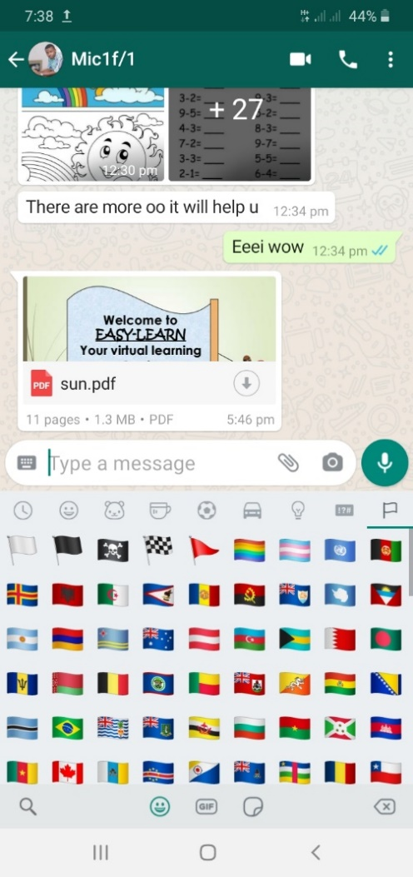  The classroom should be set up as an international classroom with different centers exhibiting different clothes and food item.  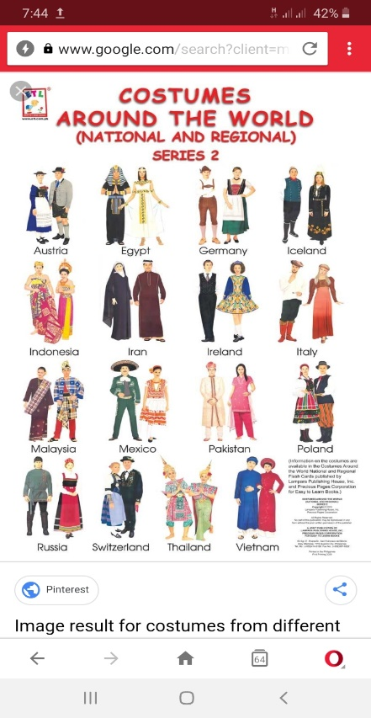  Provide learners with colorful materials, colorful papers, colorful clothes, to wear representing different countries.  Assist learners to use music and drama to demonstrate how the various countries dance.  Set up an international market in the classroom where all kinds of international traders come and shop.  Demonstrate buying and selling, practicing addition and subtraction of money and giving change.  The store keeper can receive calls from abroad for orders.  Learners sing rhymes and dance with actions. |  |  |  |  | Poster, Cut out shapes, big books, counters, crayons, cut out foreign currencies
LEARNING CENTER | Engage learners to play freely at the learning centers.  Observe, join in and ask learners questions frequently to guide their play and to support their understanding in what they are learning. |  |  |  |  | Learning center
STORY SHARING | Tell learners a story.  Pause regularly and ask questions to make sure learners are following.  Engage learners to act parts of the story.  1. Was the story interesting?  2. What part of the story did you like?  3. what have you learnt from the story? |  |  |  |  | Word cards, letter cards.
PHASE 3: REFLECTION | Learners share what they have learnt with their peers and class.  Give learners homework to do at home.

Date: |  | Day: FRIDAY |  |  | Strand: All Around Us
 |  |  |  |  | Sub Strand: Connecting & Communicating With The Global Community
Class: KG 1 |  |  | Class Size:
Content Standard:  K2.7.1.1 Demonstrate understanding of the various ways we connect with the global community. |  |  |  | Indicator:  K2.7.1.1.7 talk about the colors of the flags of other countries and other art work and music that they have.  K2.7.1.1.8 developing a conceptual understanding of addition and subtraction in the buying and selling that goes in between different countries.
Performance Indicator:  - Learners can talk about the colors of the flags of other countries and other art work and music that they have.  - Learners can developing a conceptual understanding of addition and subtraction in the buying and selling that goes in between different countries. |  |  |  |  | Core Competencies:  Communication and collaboration, Critical thinking, Personal Development and Leadership
Keywords: Position sentence, blowing breath, blow.
Reference : KG Curriculum P.g. 76-79
Phase/Duration | Learners Activities |  |  |  |  | Resources
PHASE 1: STARTER | Let learners identify the beginning sounds of the items in the picture below.  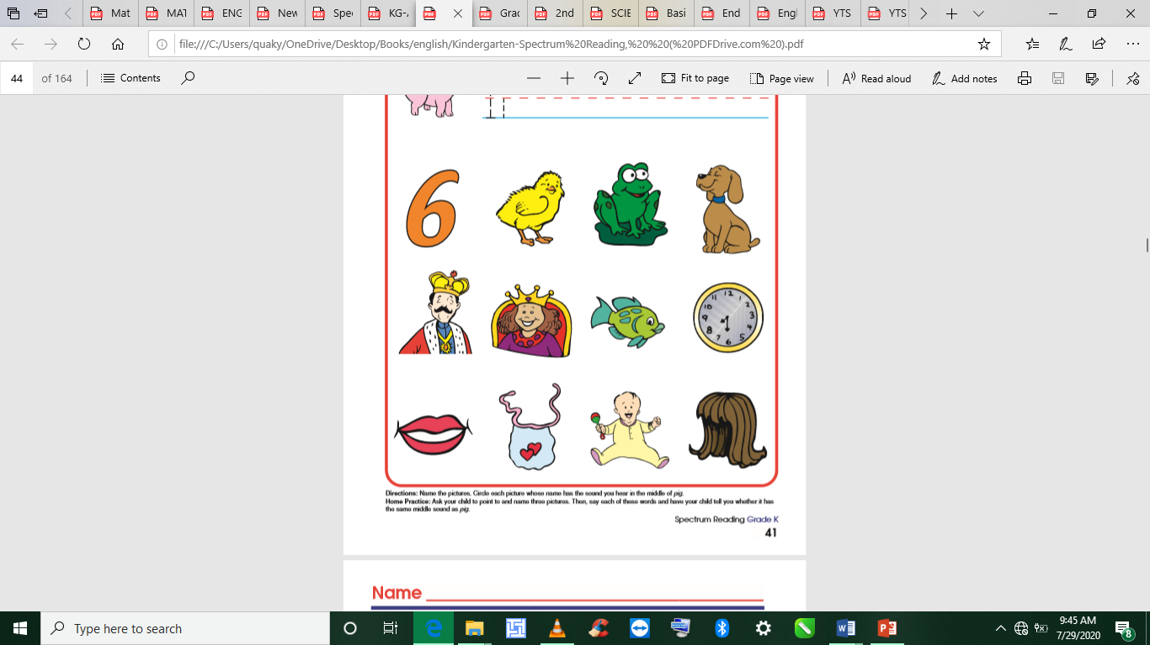
PHASE 2: NEW LEARNING  CIRCLE TIME | Learners study the flags of other countries and design different maps for the classroom.
GROUP ACTIVITY 1  (OUTDOOR) | Teacher sings songs and recite rhymes in relation to the lesson with learners  Take learners out to the field.  Guide them to swing the sea-saw, sit on the mary-go-round etc.  Sing rhymes and songs with learners as they play.
PHONICS | Engage learners to sing songs and recite some familiar rhymes that relates to the target sound.  Guide learners to pronounce and write the target sound in the sand tray or exercise books.  Have learners say three or four words that contain the target sound.  Using flash cards, learners read words that contain the target sound.  1. What sound have we learnt today?  2. Which other letter sound do you know?  3. Mention any object in the classroom or home that begins with the target letter sound. |  |  |  |  | Word cards, letter cards.
GROUP ACTIVITY 2  (INDOOR) | Learners study the flags of other countries and design different maps for the classroom.  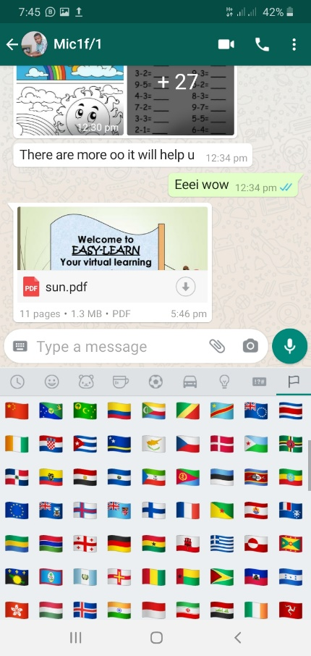  The classroom should be set up as an international classroom with different centers exhibiting different clothes and food item.  Assist learners to use music and drama to demonstrate how the various countries dance.  Set up an international market in the classroom where all kinds of international traders come and shop.  Demonstrate buying and selling, practicing addition and subtraction of money and giving change.  The store keeper can receive calls from abroad for orders.  Provide learners with colorful materials, colorful papers, colorful clothes, to wear representing different countries.  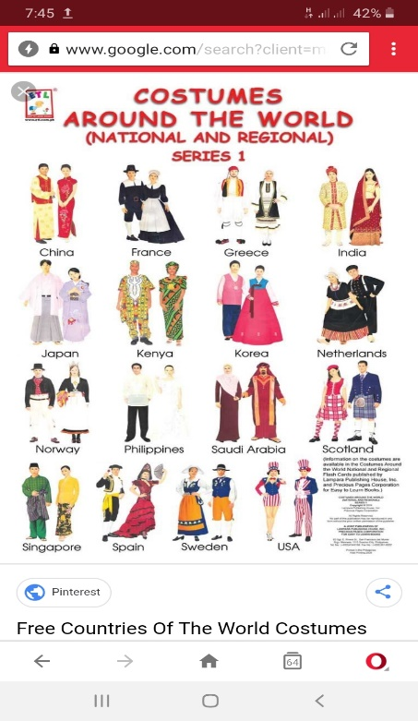  Make a choice to use any of the learning centers created |  |  |  |  | Poster, Cut out shapes, big books, counters, crayons, cut out foreign currencies
LEARNING CENTER | Engage learners to play freely at the learning centers.  Observe, join in and ask learners questions frequently to guide their play and to support their understanding in what they are learning. |  |  |  |  | Learning center
STORY SHARING | Tell learners a story.  Pause regularly and ask questions to make sure learners are following.  Engage learners to act parts of the story.  1. Was the story interesting?  2. What part of the story did you like?  3. what have you learnt from the story? |  |  |  |  | Word cards, letter cards.
PHASE 3: REFLECTION | Teacher sings songs and recite rhymes in relation to the lesson with learners  Take learners out to the field.  Guide them to swing the sea-saw, sit on the mary-go-round etc.  Sing rhymes and songs with learners as they play  Give learners homework to do at home.

